Book Management System

Project report (CA3) submitted in fulfillment of the requirements for the Degree of
BACHELOR OF TECHNOLOGY
in
COMPUTER SCIENCE AND ENGINEERING
By
Nalla Bhargav Thirupathi Rao
(12111609)
SUBJECT
INT222 – ADVANCED WEB DEVELOPMENT
Submitted To
Ms. Divya Thakur


School of Computer Science and Engineering
Lovely Professional University
Phagwara, Punjab (India)
April 2024

DECLARATION
We hereby declare that the project work entitled (“Title of the project”) is an authentic record of our own work carried out as requirements of Capstone Project for the award of B.Tech degree in ADVANCED WEB DEVELOPMENT (Programme Name) from Lovely Professional University, Phagwara, under the guidance of (Name of Faculty Mentor), during January to April 2024. All the information furnished in this project report is based on my own intensive work and is genuine.

Name of Student : N.Bhargav Thirupathi Rao
Registration Number: 12111609

(Signature of Student )


Date:29-04-2024

CERTIFICATE
This is to certify that the declaration statement made by the student is correct to the best of my knowledge and belief. He /She have completed this Project under my guidance and supervision. The present work is the result of his/her original investigation, effort and study. No part of the work has ever been submitted for any other degree at any University. The Project is fit for the submission and partial fulfillment of the conditions for the award of B.Tech degree in Computer Science Engineering from Lovely Professional University, Phagwara.

Signature and Name of the Staff : Ms.Divya Thakur

Designation

School of Computer Science and Engineering,
Lovely Professional University,
Phagwara, Punjab.

Date : 29-04-2024

Table of contents
Sl.No | Topic Name
1 | List of Figures
2 | Home Page
3 | Student Page
4 | Assign Books
5 | 1. Introduction
6 | 2. Profile of the Problem
7 | 3. Existing System
8 | 4.Problem Analysis
9 | 5. Software Requirement Analysis
10 | 6. Technologies Used
11 | 7. Modules
12 | 8.GitHub Link
13 | 9. List of References/Bibliography

1. List of Figures
1.1Home Page :
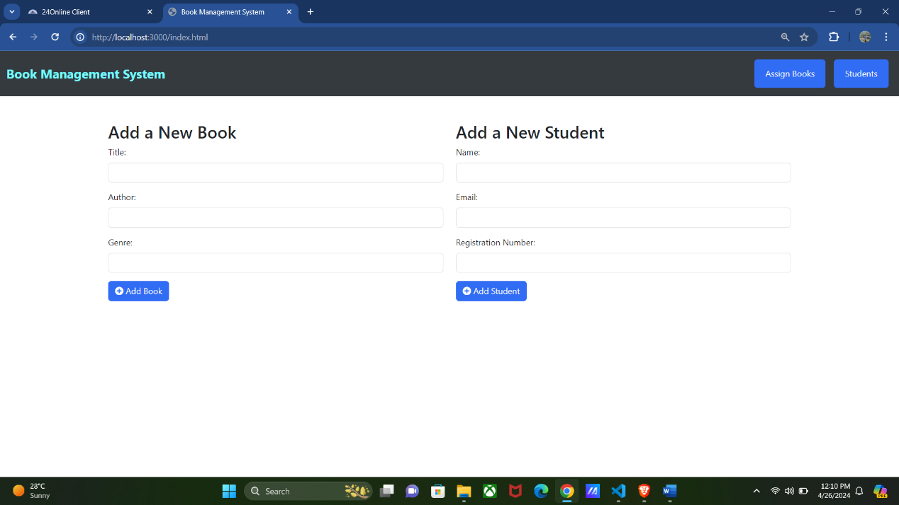

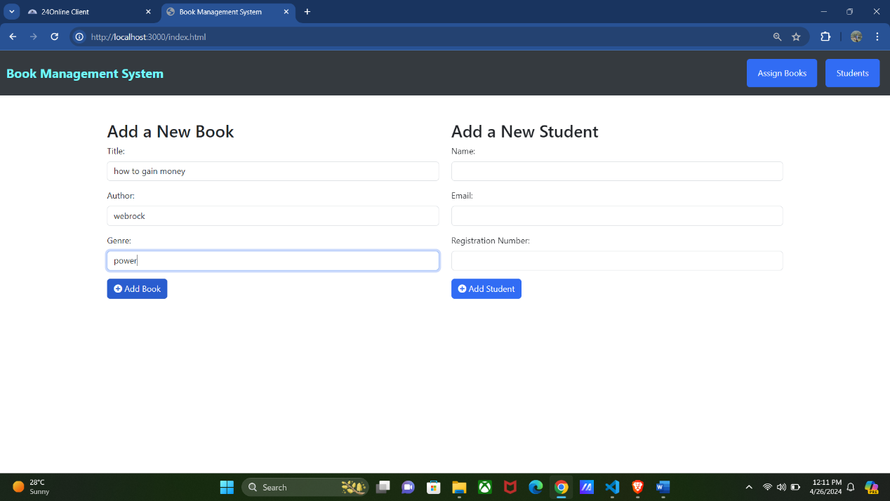

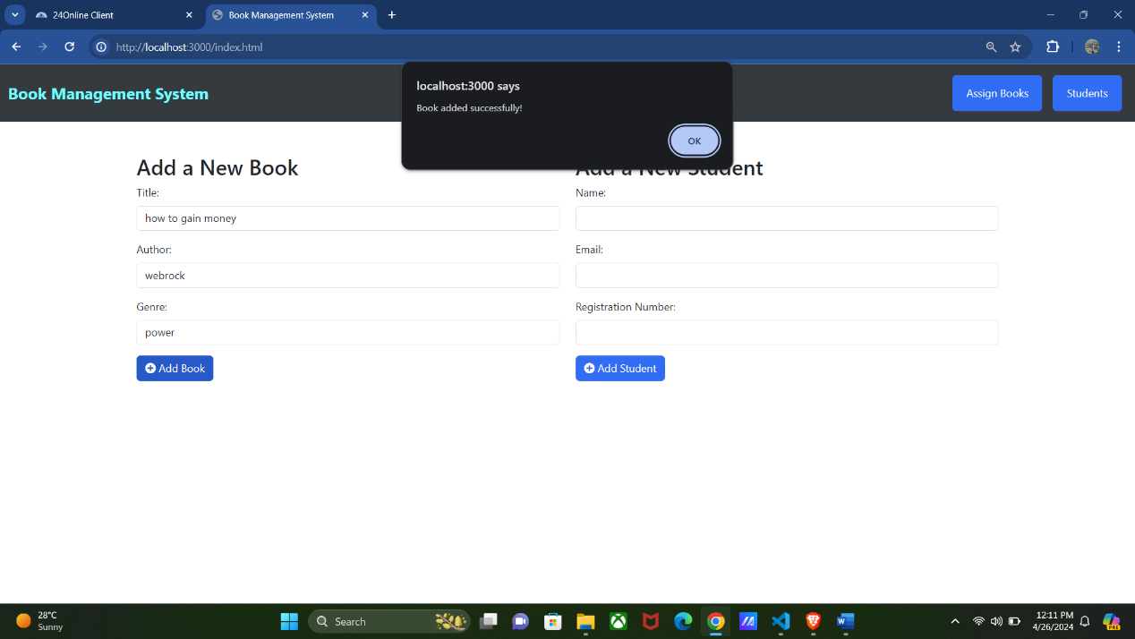

1.2StudentsPage: 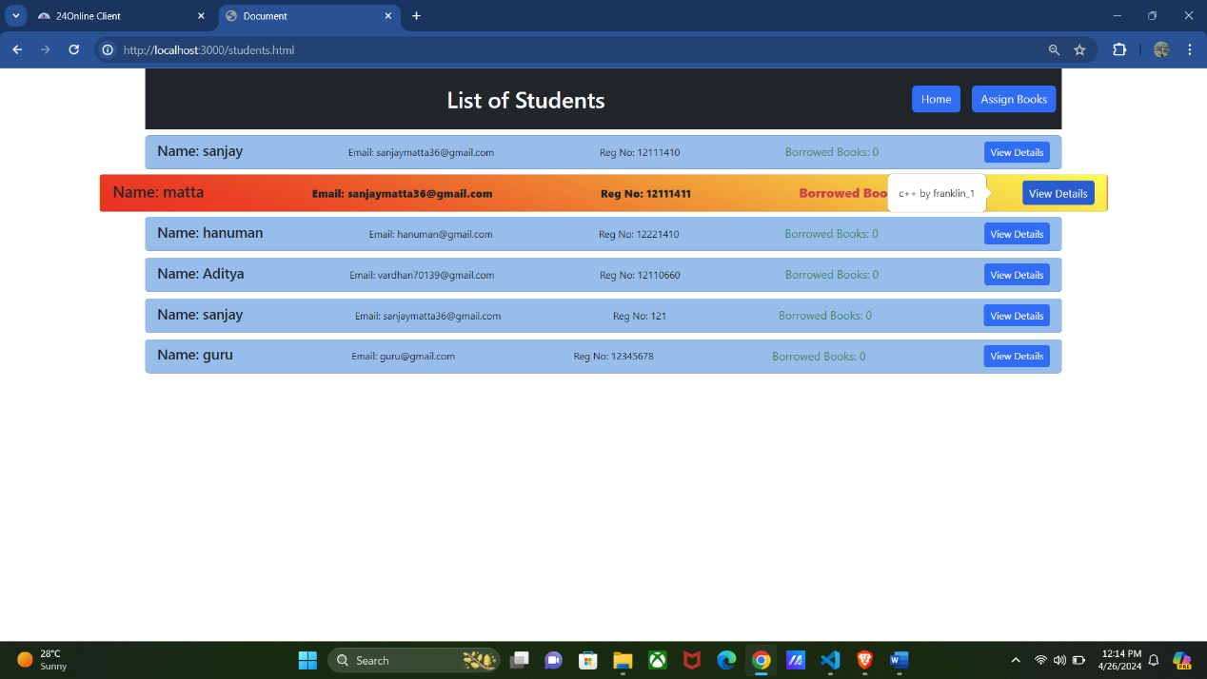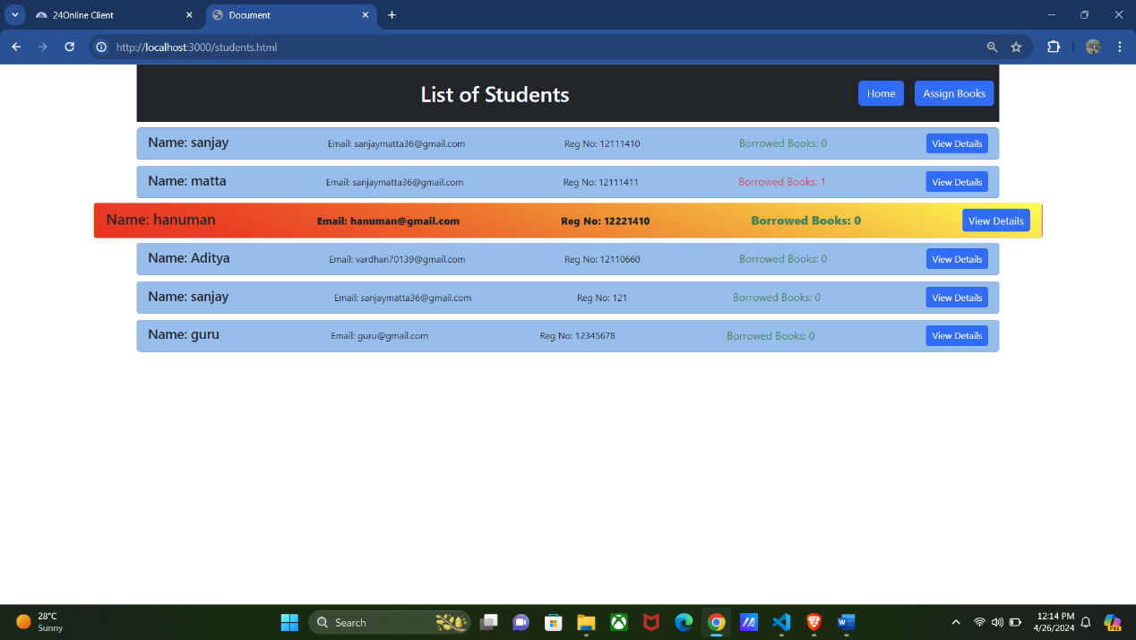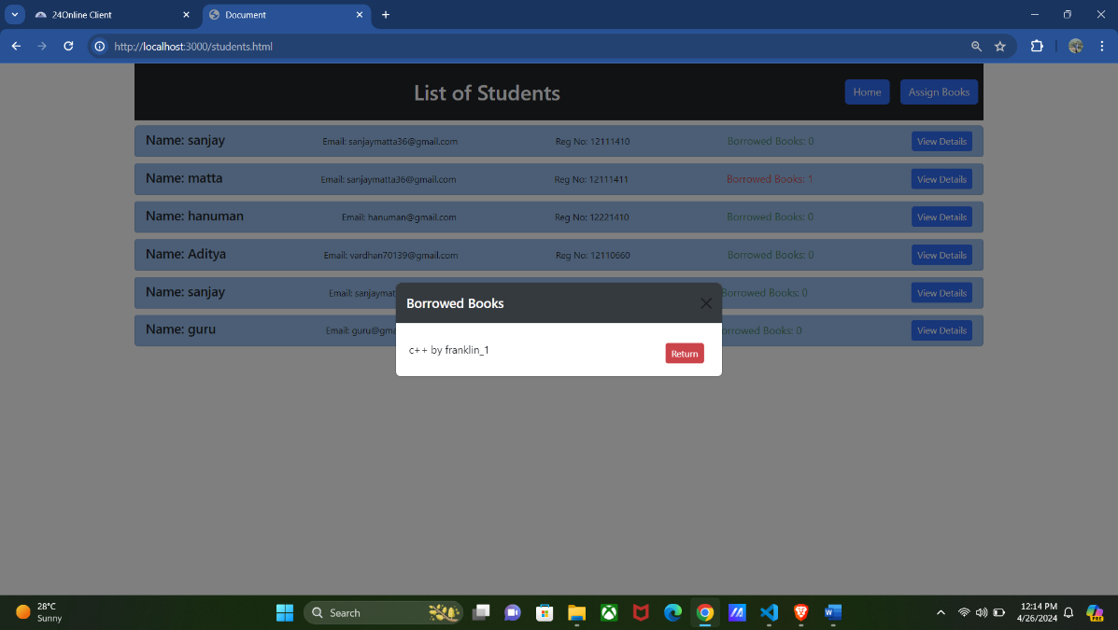
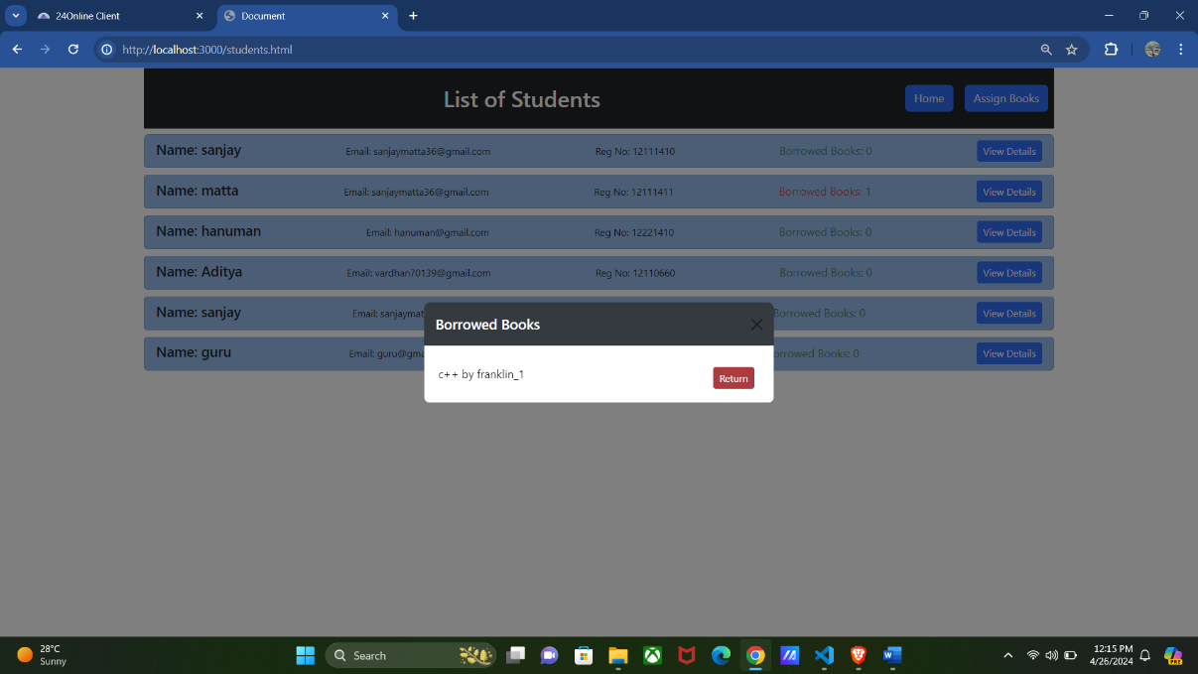

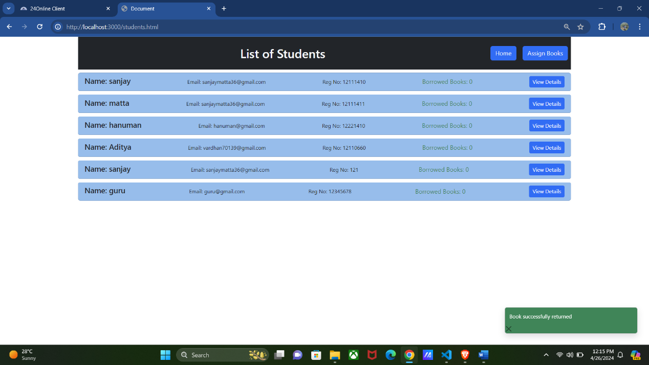

Assign Books
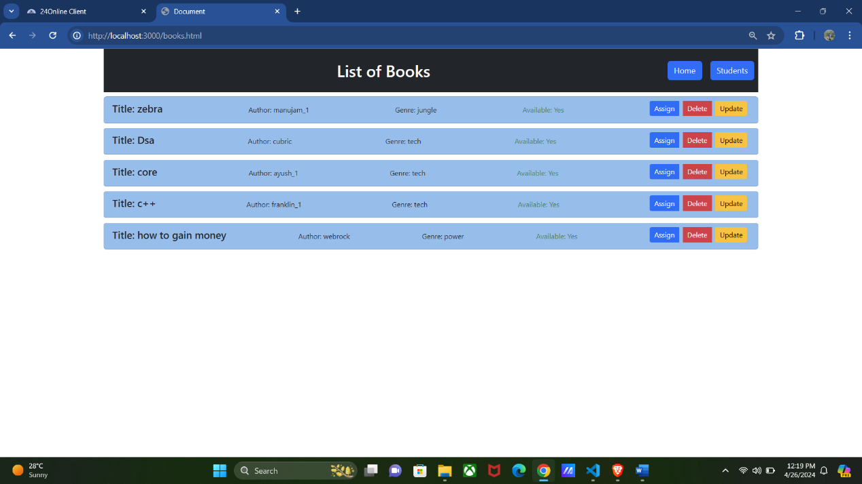
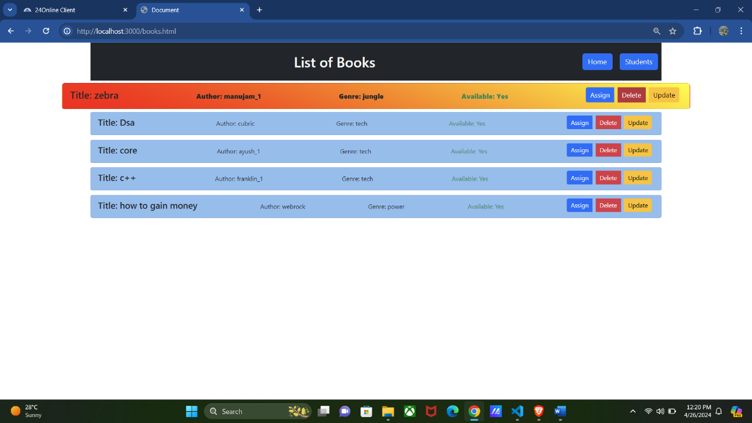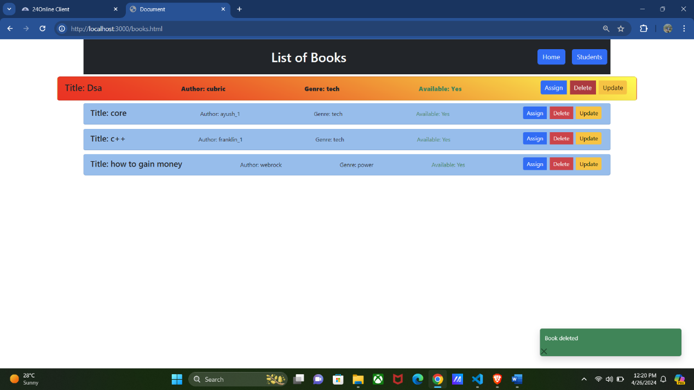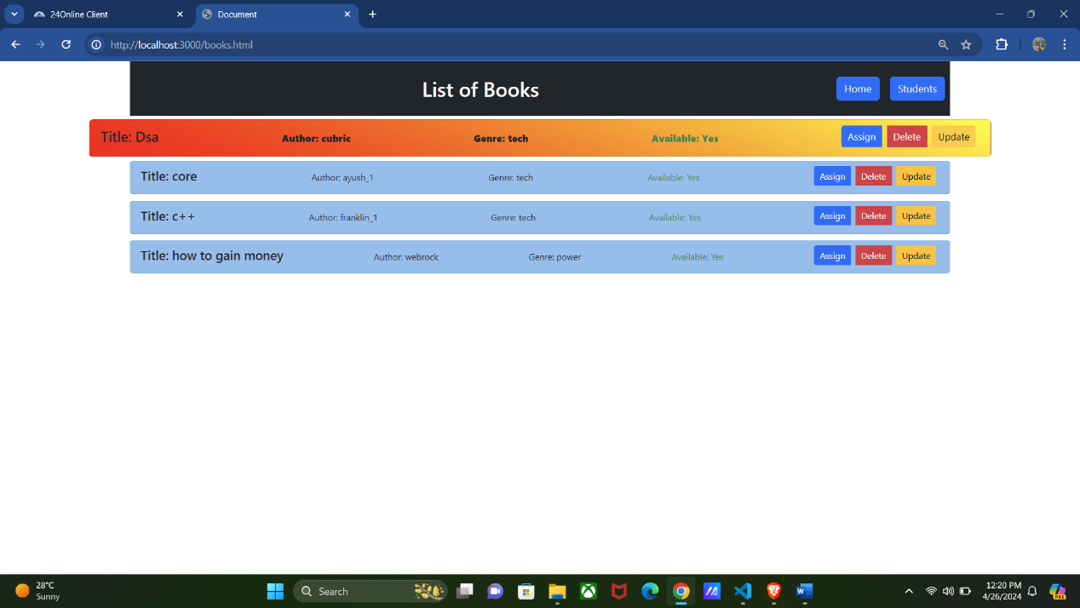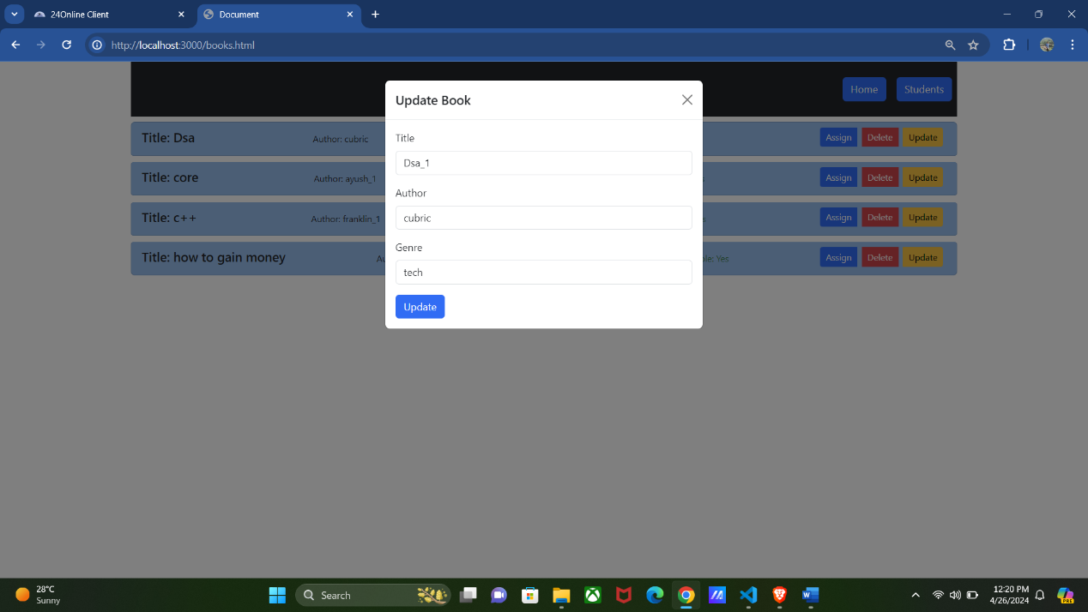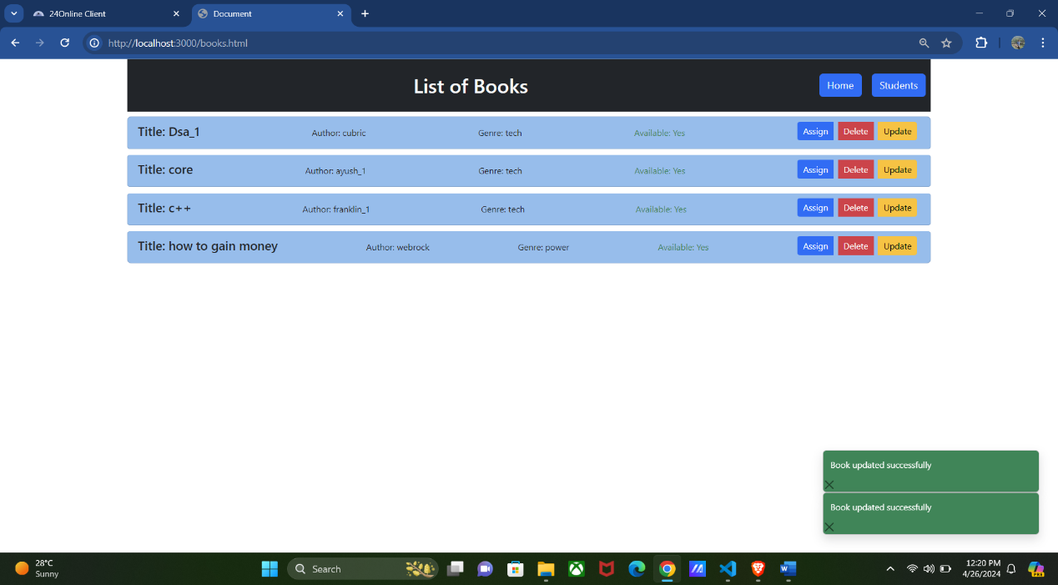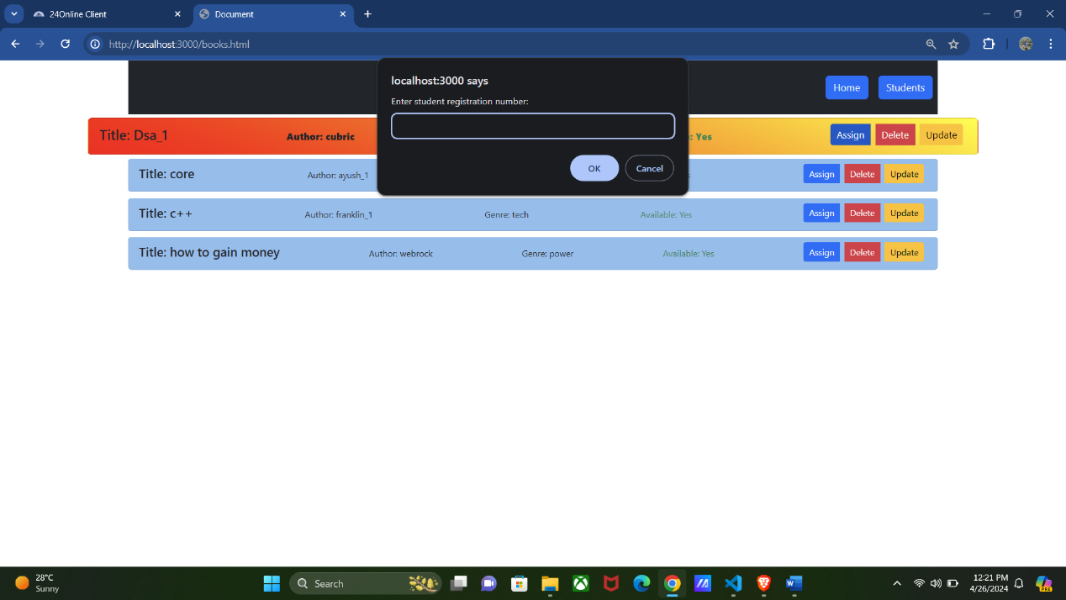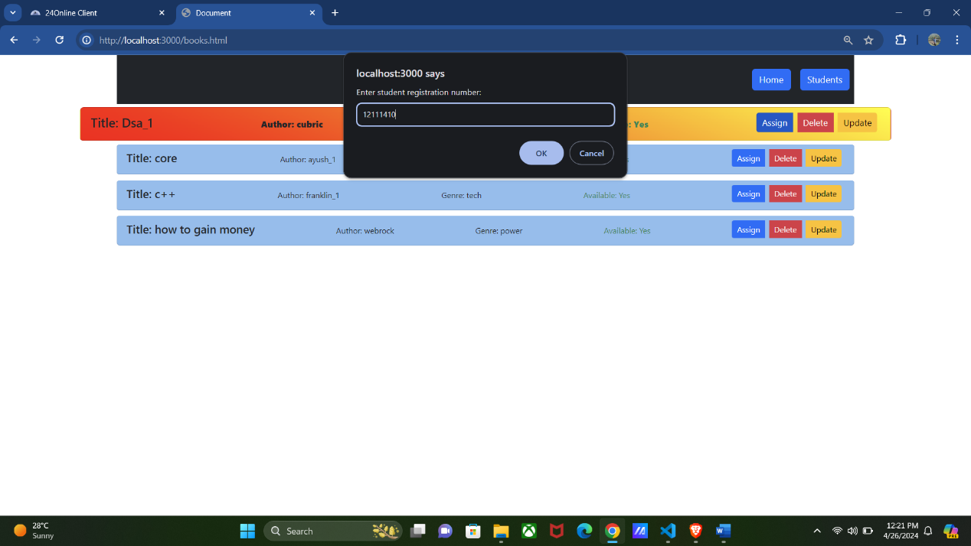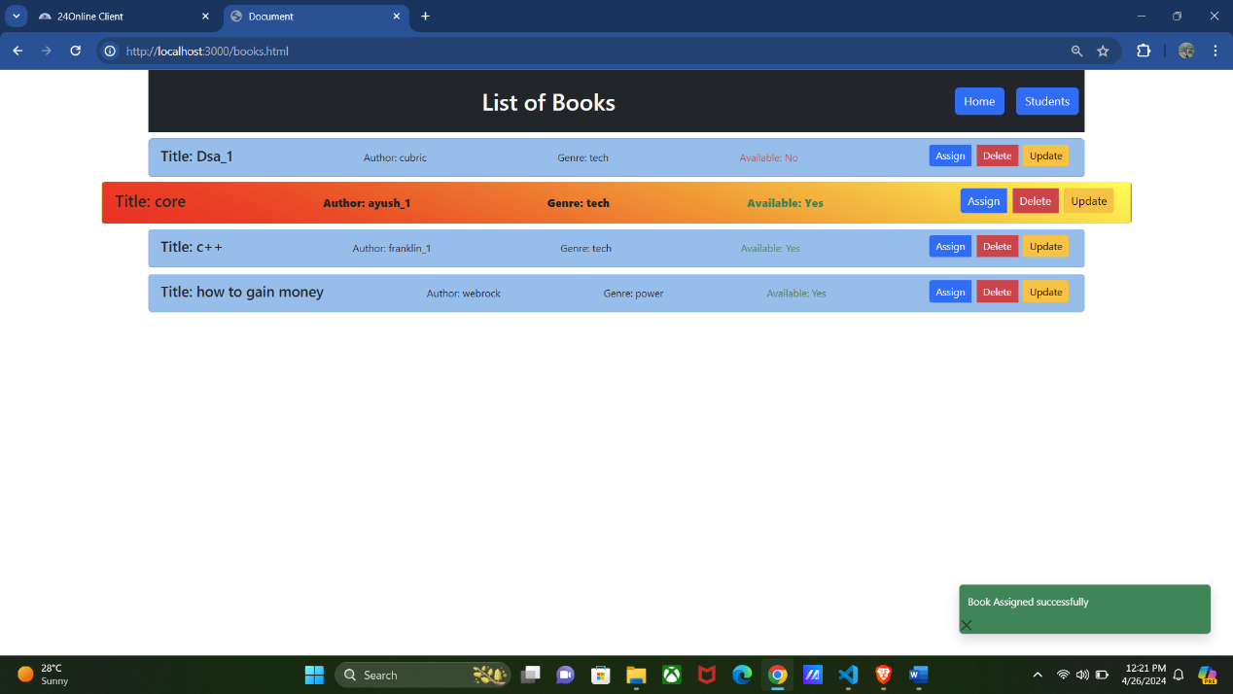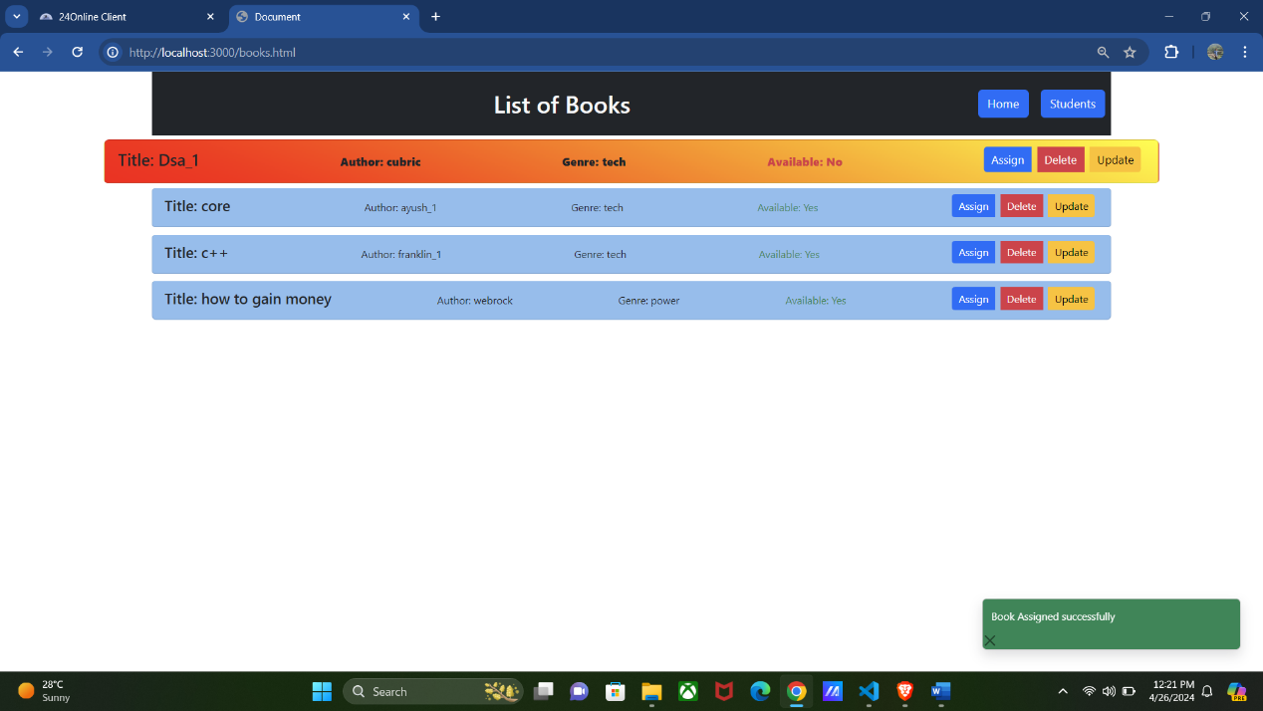

List of Abbreviations:
Home: In my project home page is the one where the user can add students and books to the database:
Assign Books: Whenever you go to this page you can able to assign a book to particular students based on the registration number and you can also see a list of books in that are available. We can also delete or update a book.
Students: On this page, we can see the list of all students and we can also get to know their details also. If a student borrows a book it will be shown here. And if we want to return the book he can do that by selecting a book.
Book Management System: This is nothing but the heading of the project.

1. Introduction
In today's fast-paced world, efficient management systems are crucial for streamlining processes and maximizing productivity. The "Book Management System" is a comprehensive solution designed to simplify the management of books and students in educational institutions or libraries. This project aims to provide a user-friendly interface for librarians or administrators to efficiently handle tasks such as adding and assigning books, managing student records, and facilitating book transactions seamlessly.
Upon accessing the system through the web interface, users are greeted with the index.html page, providing easy navigation to various functionalities. The system is built on a Node.js server, with the front-end powered by HTML and JavaScript, offering a responsive and intuitive user experience. Through a localhost server, users can access the system conveniently, ensuring accessibility and ease of use.
The core functionalities of the Book Management System revolve around three main modules: Library Management, Student Management, and Book Assignment.

Library Management:
Users can add new books to the library database, providing essential details such as title, author, genre, and ISBN. The system ensures efficient organization and categorization of books, enabling librarians to maintain an up-to-date inventory.
Student Management:
The system stores student records, including unique registration numbers and personal details. Librarians can easily add, view, or modify student information, facilitating smooth interaction and communication with library patrons.
Book Assignment:
This module allows librarians to assign books to students based on their unique registration numbers. Through the "Assign Book" page, users can select a book from the library inventory and allocate it to a specific student. Additionally, the system keeps track of book transactions, displaying relevant information such as borrower details and return dates.
With the integration of MongoDB, a robust database management system, the Book Management System ensures efficient data storage and retrieval. The use of MongoDB enables scalability and flexibility, accommodating the growing needs of educational institutions or libraries.

2. Profile of the Problem
In educational institutions and libraries, the efficient management of books and student records is essential for supporting learning and research activities. However, traditional methods of managing library resources often involve manual processes, leading to inefficiencies, inaccuracies, and challenges in maintaining up-to-date records. Librarians and administrators face numerous challenges in organizing and accessing library resources, assigning books to students, tracking book transactions, and managing student records effectively.
2.1 Rationale/Scope of the Study:
The Book Management System is developed to address these challenges and provide a comprehensive solution for managing books and student records in educational institutions and libraries. The system aims to streamline library operations, improve accessibility to library resources, and enhance the overall user experience for librarians, administrators, and students.

2.2 The primary problem addressed by the Book Management System includes:
Inefficient Book Management: Manual processes for adding, updating, and deleting book records lead to inefficiencies and inaccuracies in managing the library inventory. Librarians struggle to maintain an up-to-date inventory of books, resulting in difficulties in locating and accessing resources.
2.3 Challenges in Student Management:
Manual management of student records, including registration numbers, personal details, and book transactions, poses challenges for administrators. There is a need for a centralized system to streamline student management processes and ensure accurate records of book assignments and returns.
2.4 Lack of Transparency in Book Transactions:
The absence of a centralized system for tracking book transactions leads to a lack of transparency and accountability in book assignments and returns. Librarians face difficulties in tracking borrowed books, identifying overdue returns, and managing fines or penalties effectively.
2.5 Limited Accessibility to Library Resources: Traditional library systems may lack accessibility features, making it challenging for users to access library resources remotely or from multiple devices. There is a need for a web-based solution that provides seamless access to library resources, regardless of the user's location or device.
2.6 Scalability and Flexibility:
Educational institutions and libraries require scalable and flexible solutions that can adapt to their evolving needs and growing collections of books and student records. The Book Management System aims to provide a scalable architecture and flexible features to accommodate future growth and changes in requirements.
3. Existing System
3.1 Introduction:
The existing system for managing library resources and student records often relies on manual processes and traditional methods, which can be time-consuming, error-prone, and inefficient. Librarians and administrators face challenges in maintaining an up-to-date inventory of books, managing student records, and tracking book transactions effectively. These challenges highlight the need for a modern and comprehensive solution that streamlines library operations and enhances the overall user experience.

3.2 Existing Software:
In the current landscape, there may be various software solutions and systems used for library management, ranging from legacy systems to proprietary software. Some common features of existing library management systems may include:

Book Cataloging: Allowing librarians to add, edit, and delete book records, including details such as title, author, ISBN, and genre.
Student Management: Providing functionality for managing student records, including registration numbers, personal details, and borrowing history.
Book Transactions: Facilitating book transactions, such as assigning books to students, tracking borrowed books, and managing returns.
Reporting and Analytics: Generating reports and analytics on library usage, overdue books, popular titles, and student borrowing patterns.
Accessibility: Offering accessibility features for users to access library resources remotely or from multiple devices. Despite these features, existing software solutions may still have limitations in terms of usability, scalability, and flexibility. Many systems may lack modern web-based interfaces, real-time updates, and integration capabilities with other systems, leading to inefficiencies in library operations.

3.3 What's New in the System to be Developed:
The proposed Book Management System introduces several innovative features and enhancements to address the limitations of existing systems. Some key aspects of the new system include:

Modern Web Interface: The new system will feature a modern, web-based interface built using HTML, CSS, and JavaScript, providing a responsive and intuitive user experience across devices.
Real-Time Updates: Leveraging technologies such as Node.js and Express.js, the system will offer real-time updates for book transactions, ensuring timely and accurate information for librarians and students.
Integration with MongoDB: The system will utilize MongoDB as the database management system, offering scalability, flexibility, and seamless integration with other technologies.
Enhanced Student Management: Introducing features for managing student records more efficiently, including advanced search functionalities, personalized user profiles, and automated notifications for overdue books.
Improved Accessibility: Ensuring accessibility features to enable users to access library resources from anywhere, at any time, through a web-based interface optimized for accessibility standards.
4.Problem Analysis
4.1 Product Definition
The Book Management System is a web-based application designed to streamline library operations, facilitate book transactions, and manage student records effectively. The primary goal of the system is to provide a user-friendly interface for librarians or administrators to efficiently manage library resources and student information.
Key Features:
Book Cataloguing: Librarians can add, edit, and delete book records, including details such as title, author, genre, ISBN, and availability status.
Student Management: The system enables administrators to manage student records, including registration numbers, personal details, and borrowing history.
Book Assignment: Facilitates the assignment of books to students based on registration numbers, tracks borrowed books, and manages returns seamlessly.
Real-Time Updates: Offers real-time updates for book transactions, ensuring timely and accurate information for librarians and students.
Reporting and Analytics: Generates reports and analytics on library usage, overdue books, popular titles, and student borrowing patterns.
Accessibility: Provides accessibility features for users to access library resources remotely or from multiple devices.

4.2 Feasibility Analysis:
Technical Feasibility: The project utilizes modern web development technologies such as HTML, CSS, JavaScript, Node.js, Express.js, and MongoDB. These technologies are widely used, well-supported, and offer scalability and flexibility for building robust web applications. Additionally, the integration of MongoDB provides a scalable solution for data storage and management.
Operational Feasibility: The Book Management System offers a user-friendly interface that simplifies library operations and reduces manual efforts. It enhances operational efficiency by automating tasks such as book cataloging, student management, and book transactions. With real-time updates and reporting capabilities, the system enables administrators to make informed decisions and optimize library resources effectively.
Economic Feasibility: The project's economic feasibility is assessed based on the cost-effectiveness of development and maintenance. By leveraging open-source technologies and frameworks, the development costs are minimized. Additionally, the system's scalability and flexibility reduce long-term maintenance costs, making it a cost-effective solution for educational institutions or libraries.
Legal and Ethical Feasibility: The Book Management System complies with legal and ethical standards regarding data privacy, security, and accessibility. It adheres to regulations such as GDPR (General Data Protection Regulation) and ensures that sensitive information such as student records is handled securely and ethically.

4.3 Project Plan:
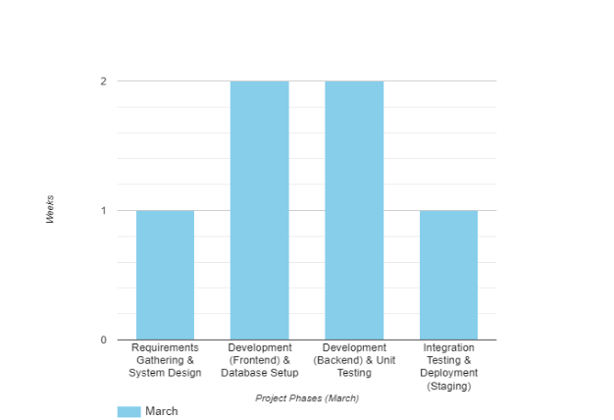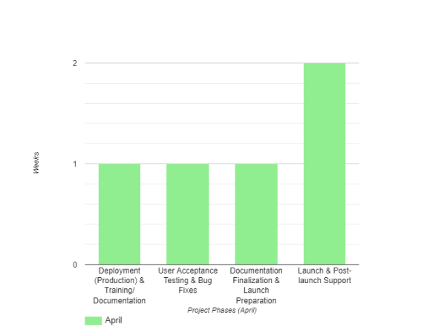

5. Software Requirement Analysis
General Description:
The software requirement analysis for the Book Management System involves understanding the functional and non-functional requirements of the system. This analysis aims to define the features, capabilities, and constraints of the software to be developed.

5.1 Specific Requirements:
1.Functional Requirements:
User Authentication: Users must be able to log in securely with valid credentials.
Add Book: The system should allow administrators to add new books to the library inventory by providing details such as title, author, genre, and ISBN.
Manage Students: Administrators should be able to add, view, update, and delete student records, including personal details and registration numbers.
Assign Book: Librarians should have the ability to assign books to students based on their registration numbers and track book transactions.
Return Book: Students should be able to return borrowed books, updating the system's inventory and transaction records accordingly.
Search Functionality: Users should be able to search for books or students using relevant keywords or criteria.
View Reports: Administrators should have access to generate reports on book transactions, student records, and inventory status.

2.Non-Functional Requirements:
Security: The system should implement robust security measures to protect user data and prevent unauthorized access.
Performance: The application should be responsive and performant, even under high loads, ensuring smooth user experience.
Scalability: The system should be scalable to accommodate future growth in terms of users, books, and transactions.
Reliability: The application should be reliable, with minimal downtime and accurate data processing.
Usability: The user interface should be intuitive and user-friendly, requiring minimal training for users to navigate and perform tasks.
Compatibility: The system should be compatible with different web browsers and devices to ensure broad accessibility.

6. Technologies Used:
The Book Management System project leverages a combination of front-end and back-end technologies to deliver a robust and user-friendly solution. The following technologies were utilized:

Front-end Development:
HTML: Used to structure the web pages and create the user interface.
Bootstrap: Employed for responsive design and layout components, enhancing the visual appeal and usability of the application.
CSS: Implemented to style the HTML elements and enhance the overall presentation of the user interface.
Back-end Development:
Express.js/Node.js: Utilized as the server-side framework to handle HTTP requests and responses, enabling the creation of a dynamic and interactive web application.
MongoDB: Employed as the database management system to store and manage data related to books, students, and library transactions. MongoDB's flexibility and scalability make it an ideal choice for handling diverse data requirements.

7.Modules:
The Book Management System project consists of several modules or components, each serving a specific purpose within the system. These modules work together to provide a comprehensive solution for managing books and students efficiently. The key modules/components include:
User Interface (UI):
Index Page: The landing page of the application, providing navigation to various functionalities.
Students Page: Displays a list of students and their relevant information.
Assign Book Page: Allows librarians to assign books to students and manage book transactions.
Library Management Page: Facilitates the addition of new books to the library inventory and manages book details.
Backend Server:
Express.js/Node.js Server.js: Handles HTTP requests and responses, serves as the backend logic for processing user interactions, and communicates with the database.
Database Management:
Modals/students.js/books.js: Stores and manages data related to books, students, and library transactions. Provides a flexible and scalable solution for data storage.
Functionality Modules:
Add Book: Enables librarians to add new books to the library inventory, providing essential details such as title, author, genre, and ISBN.
Manage Students: Allows administrators to add, view, or modify student records, including unique registration numbers and personal details.
Assign/Return Book: Facilitates the assignment of books to students and tracks book transactions, including borrower details and return dates.
Update/Delete Book: Provides functionality to update or delete existing book records from the library inventory.
Integration Modules:
Bootstrap: Utilized for responsive design and layout components, enhancing the visual appeal and usability of the application.
CSS Styling: Implements custom styling to enhance the overall presentation of the user interface.
8.GitHub Link:
Github: https://github.com/Bhargav0326/Book-Management

9. List of References/Bibliography:
Code Snippets/Lectures: By Dr. Senthil Kumar J
W3Schools("HTML Tutorial." ):Retrieved from https://www.w3schools.com/html/
BootstrapDocumentation"GettingStarted.":Retrievedfrom https://getbootstrap.com/docs/5.1/getting-started/introduction/
Node.jsDocumentation."API reference.": Retrievedfrom https://nodejs.org/en/docs/
MongoDBDocumentation."Manual.":Retrievedfrom https://docs.mongodb.com/manual/
Express.jsDocumentation.Retrieved from
https://expressjs.com/en/guide/routing.html

